Preparation

**Modules Learnt:**

**Matplotlib –** Used for plotting graphs

**Numpy –** Can be used for reading in files (Pandas was also used here) and working with arrays as well as performing some mathematical functions

**Scipy:** Learnt how to create and manipulate matrices, as well as curve fitting and interpolation

**Datetime –** Used to display things in Datetime format, and how to convert to other time zones

**Argparse –** used to run program from command terminal as well as with shortcut commands and how to fill in the help command and use mutually exclusive commands that change the form of the output.

Watched YouTube tutorials for each of them (the most viewed ones)

Learnt how to use and install Jupyter notebook on a personal device

Physics

**What is air shower?**

An air shower is a shower of ionized particles and radiation produced in the atmosphere when a cosmic ray enters the atmosphere. When a particle from the cosmic ray strikes an atom's nucleus in the atmosphere, it produces many energetic hadrons. The unstable hadrons decay into other particles and radiation. The secondary radiation rains down, which also includes muons, protons and alpha particles.

**What is a cosmic ray?**

Cosmic rays are high-energy protons and atomic nuclei that move through space at nearly the speed of light. Upon impact with Earth's atmosphere, cosmic rays produce showers of secondary particles, some of which reach the surface (these are air showers).

**What is a hadron?**

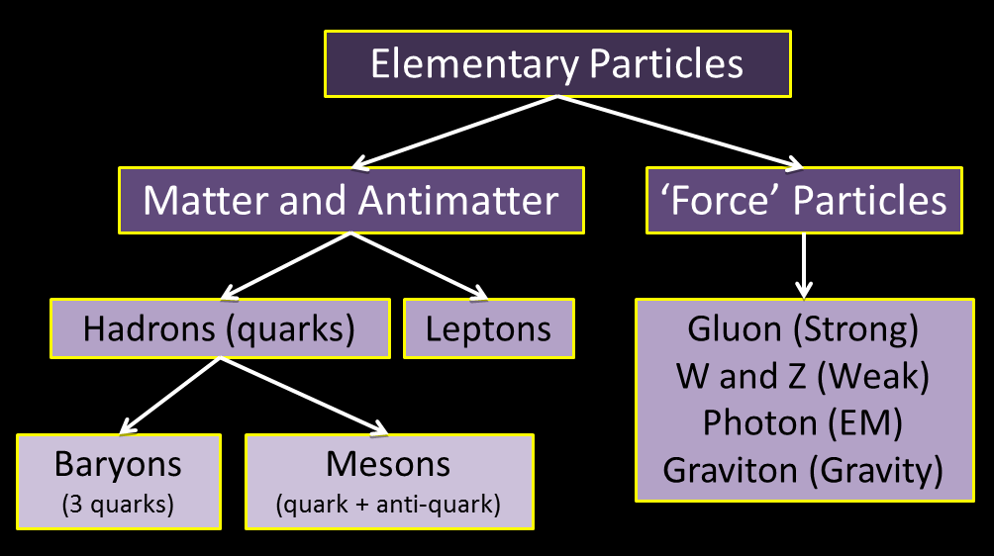

**What is Cherenkov radiation?**

Cherenkov radiation is emitted when a charged particle passes through a dielectric medium at a speed greater than the phase velocity of light in that medium

When a high-energy gamma photon or cosmic ray interacts with the atmosphere, it may produce an electron-positron pair with enormous velocities. The Cherenkov radiation emitted in the atmosphere by these charged particles is used to determine the direction and energy of the cosmic ray or gamma ray.

Astrophysics observatories using the Cherenkov technique to measure air showers are key to determine the properties of astronomical objects that emit very high energy gamma rays.

**What is a muon?**

A muon is an elementary particle similar to the electron, with an electric charge of −1 but with a much greater mass.

**What is the water experiment thing?**

There is a vase of water in a dark box so when the muons reach the water, the phase velocity of the muons that surpass the speed of light in the same medium produces Cherenkov radiation which is detected by the pixel sensors, converted to voltage, and ADC converts the voltage to a signal, which is transferred to a computer.

**What is doping?**

In a semiconductor doping is the process of adding different elements to a semiconductor to change its conductivity, and these elements are impurities. This is done to create diodes, transistors and semiconductor switches.

Data analysis

**Which modules were used?**

Matplotlib, Numpy (one use of pandas), Datetime

**What software was learnt?**

Learnt how to user Spyder (anaconda) and install some modules.

**How many file versions and what are each changes?**

|  |  |
| --- | --- |
| Version |  |
| 0a | Initial creation |
| 0b | Found the x-axis value of peak and trigger times |
| 0c | Changed technique of finding x value of peak by using numpy.where |
| 0d | Added datetime features - didn’t work properly, change file.write so it would be done in tabs (\t) so it could add into excel easily |
| 0e | Cleaned up code by deleting comments |
| 1a | Cleaned up code and performing on muon data now |
| 1b | Now doing data for 31st of July |
| 1c | Plotted for 4 simultaneous muon results |
| 1d | Found the range of minimum and maximum peaks |
| 1e | Got rid of unusual data |
| Histogram file | Created a histogram that took into account the minimum and maximum time differences for every (successfully) recorded muon |
| Example of a graph |  |

**What did I teach partner?**

Taught him how to use basics of python techniques (such as declaring variables and concatenation) and Matplotlib to plot graphs (scatter, bar, line) with labels, titles and patterns as well as how to read data in from a file and some general use on array structure types as well as casting.

**New techniques learnt?**

I learnt that using ‘\t’ instead of ‘\n’ is better for presentation of the text file, as it also allows a neater conversion to excel.

You can transfer data from a text file to the cells in excel by going to file explorer, dragging to an open excel workbook in the lower fixed menu ribbon of computer, and then placing on a cell in excel.

Datetime cannot be used at a nanosecond precision

A way to work on a coding project is to have one main file, and whenever there is significant progress, go to file explorer and copy the main file, and renaming the copied file to a new version number. Version updates should also be stated in the introduction documentation of the code.

Learnt how to use a different string format technique instead of concatenating variables by print("Line{}: {}".format(count, line.strip())) ---- format can also be assigned to a variable instead of just printing it out directly.

How to download data analysis feature in excel: File – options, Add ins – analysis Tool Pak

Using file.close() helps the text file update its data much quicker.

Learnt new functions available with Numpy and Matplotlib, such as axis limits, and the where function.

General

Learnt what the difference between a master’s degree and a PHD is

Learnt what a VIVA is

Shown physics machines and their purposes as well as the basic behaviour and functions of an oscilloscope.

Learnt about the p-n junction – when you add impurities to a semiconductor, you end up with a p type side and an n type side. p type side has holes, n type has excess of electrons, junction is the bit separating both the sides.

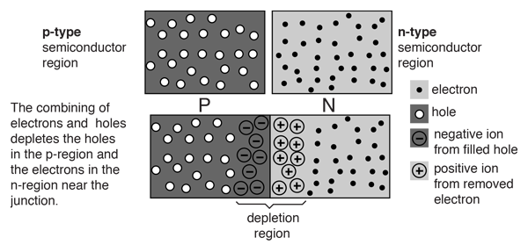

-Maryam